**Read Me**

IDE: eclipse Neon

Java Version: Java 8

In the src folder -> package expensetracker -> ExpenseTracker.java (has the main).

res folder -> datafile.txt has the data for the application to read.

**JavaDocs**

doc folder -> expensetracker -> the javadocs for different classes in html form can be found.

1. BarChartView.html
2. ExpenseController.html
3. ExpenseTracker.html
4. ExpenseUtil.html
5. PiechartView.html
6. TableView.html

**Screen Shot of Application**

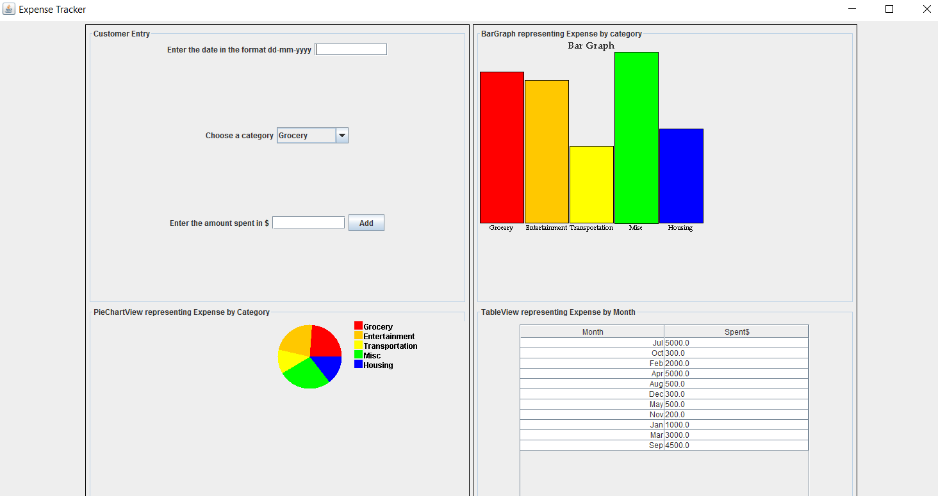

Note: Click of add button will change all the views according to the category, date and amount spent

Have implemented a third view, requirements were only two views Bar Chart and Table, 3rd view: Pie chart for displaying expense by category.